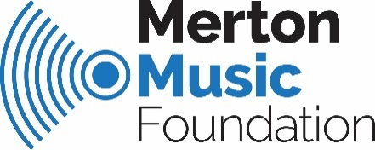
Sound Ideas The Elements Progression Y1 – 6
Timbre

 | LEARNING OBJECTIVES | LEARNING OUTCOMES
YEAR 1 | - Different sound sources produce different sound qualities – every instrument has its own unique ‘voice’ e.g. a violin sounds different from a trumpet; Dan’s voice sounds different from Sarah’s etc.  - An instrument can make a range of different sounds. | - Begin to recognise and name different sound sources and describe them using appropriate vocabulary e.g. wobbly, squeaky, rough etc.  - Begin to identify how a sound has been produced e.g. by blowing, plucking, tapping, shaking etc.  - Use percussion instruments and voices in different ways with growing awareness of the effect created.
YEAR 2 | - Different sound sources produce different sound qualities.  - An instrument can make a range of different sounds depending on how it is played. | - Recognise and name different class room percussion instruments.  - Begin to recognise and name different orchestral instruments according to ‘family’ – brass, wind, strings, and percussion.  - Describe an instrumental / vocal sound using appropriate vocabulary.  - Compose simple pieces to create a specific mood or effect.
YEAR 3 | - Every voice / instrument has its own unique sound qualities.  - Sounds can be selected and combined to produce a particular effect, mood or feeling. | - Distinguish aurally between different sounds (vocal and instrumental) using appropriate descriptive vocabulary.  - Select appropriate sounds in simple compositions and to accompany known songs.  - Use own voice / instrument in different ways with increasing control.  - Use voice expressively in songs with some awareness of effect created.
YEAR 4 | - Every voice / instrument has its own unique sound qualities.  - Sounds can be selected and combined to produce a particular effect, mood or feeling. | - Distinguish specifically between different sounds (vocal and instrumental) using appropriate descriptive vocabulary.  - Select appropriate sounds in compositions and to accompany known songs.  - Use own voice / instrument in different ways with good control.  - Use voice expressively in songs with awareness of effect created.
YEAR 5 | - Timbre is an expressive element in music that is used to achieve particular effects and moods. | - Continue to use the elements expressively in performances and composition with control and awareness of their effect.
YEAR 6 | - Timbre is an expressive element in music that is used to achieve particular effects and moods | - Describe and compare different kinds of music using appropriate musical vocabulary.  - Create and perform music that meets intentions and combines sounds imaginatively with awareness and understanding.

Soo Bishop, MMF Programmes Director
Sound Ideas KS1 and 2 October 2019

